Scatterplot: BMR vs bathymetry, coloured by ice draft depth. To incorporate grounding line proximity into my scatterplot as a marker shape:
CREATING A PROXIMITY RASTER:
- Load/create a polyline shapefile which traces the grounding line
- Rasterise the grounding line
  - Click Rasterise (vector to raster): this creates a raster for the grounding line shapefile
    - input layer: grounding line shapefile
    - burn in value field: set to 1
    - output raster size units: pixels?
    - Set width and height to match reference raster
  - Compute proximity: this creates a raster which calculates the distance to the GL shapefile
    - In processing toolbox, search Proximity (Raster Distance)
      - Input raster is the rasterised grounding line
      - Values to calculate distances for: 1

After proximity raster is calculated and exported, add path and run the following code:
import rasterio
import numpy as np
import matplotlib.pyplot as plt
import matplotlib.lines as mlines

# Load rasters
with rasterio.open("WAOM_2011_BMR.tif") as src1, \
rasterio.open("WAOM_2011_h_bathymetry.tif") as src2, \
rasterio.open("WAOM_2011_zice_ice_draft.tif") as src3, \
rasterio.open("draft_proximity_map_to_grounding_line.tif") as src4: # Grounding line proximity

z1 = src1.read(1) # BMR
z2 = src2.read(1) # Bathymetry
z3 = src3.read(1) # Ice draft
z4 = src4.read(1) # Distance to grounding line

nodata1, nodata2, nodata3, nodata4 = src1.nodata, src2.nodata, src3.nodata, src4.nodata

# Create mask
mask = (~np.isnan(z1)) & (~np.isnan(z2)) & (~np.isnan(z3)) & (~np.isnan(z4))
if nodata1 is not None: mask &= (z1 != nodata1)
if nodata2 is not None: mask &= (z2 != nodata2)
if nodata3 is not None: mask &= (z3 != nodata3)
if nodata4 is not None: mask &= (z4 != nodata4)
mask &= (z1 != 0)

# Apply mask
z1_valid = z1[mask].flatten() * (365 * 24 * 60 * 60) # BMR in m/yr
z2_valid = z2[mask].flatten() # Bathymetry
z3_valid = np.abs(z3[mask].flatten()) # Ice draft depth
z4_valid = z4[mask].flatten() # Grounding line proximity

# Bin grounding line distances into categories
bins = [0, 2, 5, 30, np.inf] # in meters
bin_labels = ["<2 pixels", "2-5 pixels", "5-30 pixels", ">30 pixels"]
shapes = ['o', 's', '^', 'x'] # circle, square, triangle, x

bin_indices = np.digitize(z4_valid, bins) - 1

# Plot
#plt.figure(figsize=(160/25.4, 100/25.4))
plt.figure(figsize=(12, 8))

for i in range(len(bins) - 1):
idx = bin_indices == i
plt.scatter(z1_valid[idx], z2_valid[idx],
c=z3_valid[idx], cmap='viridis',
s=20, marker=shapes[i], label=bin_labels[i])

# Labels and colorbar
plt.xlabel("BMR (m/yr)", fontsize=12, fontfamily='Times New Roman')
plt.ylabel("Bathymetry (m)", fontsize=12, fontfamily='Times New Roman')
plt.tick_params(direction='in')
plt.xticks(fontsize=12, fontfamily='Times New Roman')
plt.yticks(fontsize=12, fontfamily='Times New Roman')

cbar = plt.colorbar()
cbar.set_label("Ice Draft Depth (m)", fontsize=12, fontfamily='Times New Roman')
cbar.ax.tick_params(labelsize=12)
for tick in cbar.ax.get_yticklabels():
tick.set_fontfamily('Times New Roman')

legend_handles = [
mlines.Line2D([], [], color='black', marker=shapes[i], linestyle='None',
markersize=6, label=bin_labels[i])
for i in range(len(bin_labels))
]
plt.legend(handles=legend_handles, title="Distance to GL", fontsize=10, loc='lower right')
plt.tight_layout()

# plt.savefig('WAOM_scatter_BMR_Bathymetry_Thickness_proximity_to_GL.jpg', dpi=500, bbox_inches='tight')

plt.show()

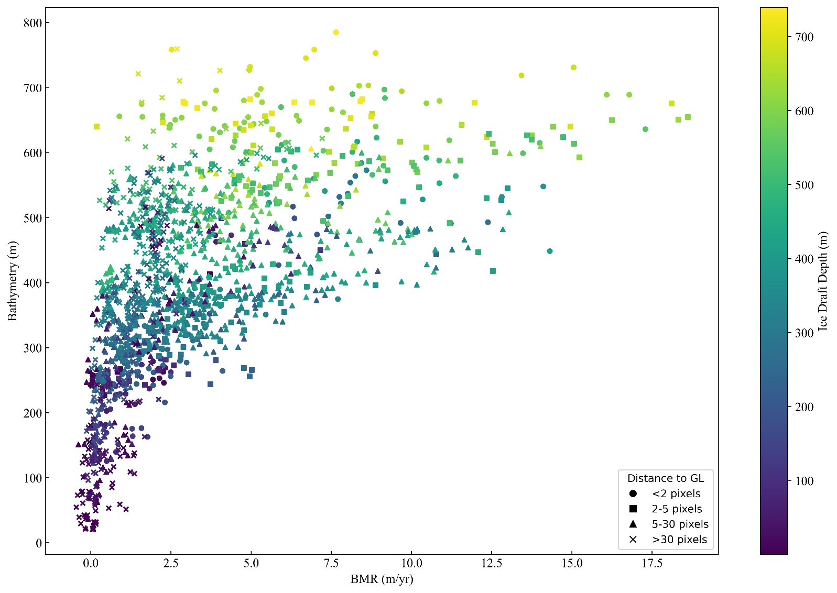

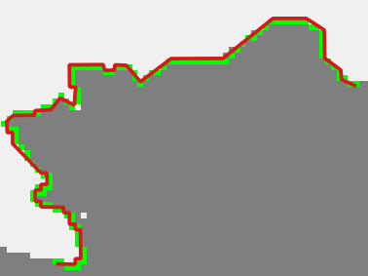
- The red shapefile is the GL shapefile
- The green pixels are the rasterised versions of the red GL

